HTTPS for application (certificate manager)

Add your domain name in route 53

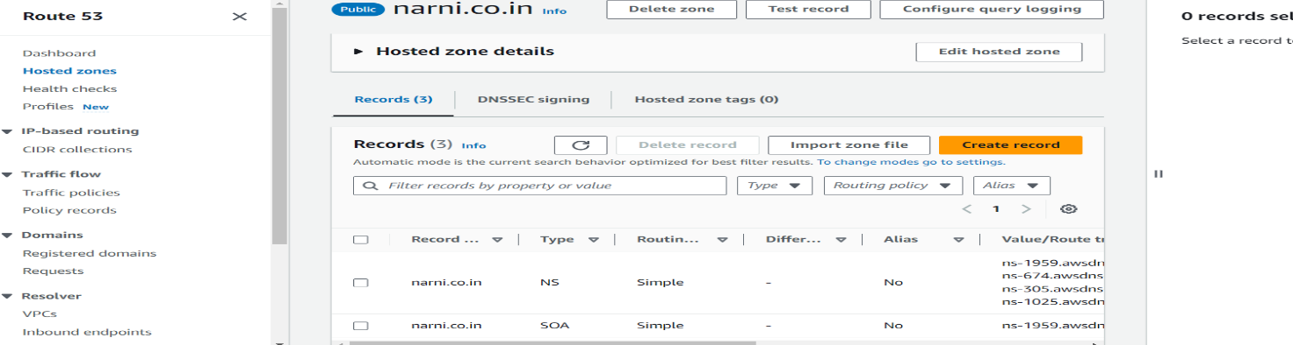

Then search for certificate manager in aws search open it

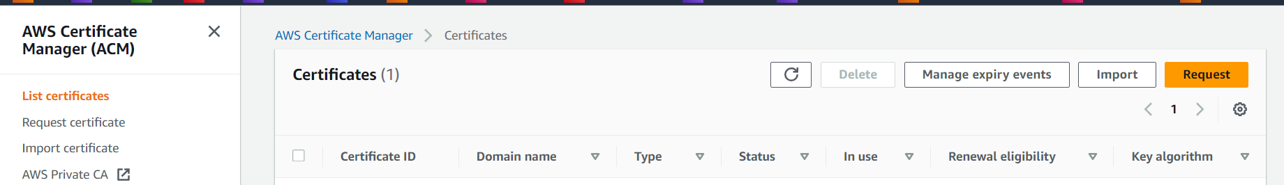

Click on request

Then click on next

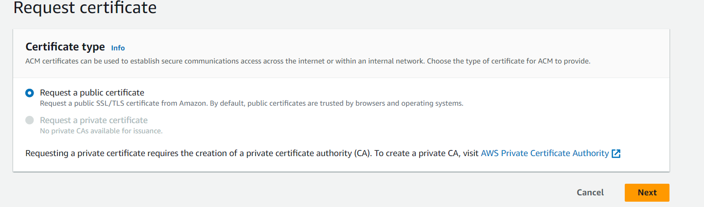

Enter your domain name here

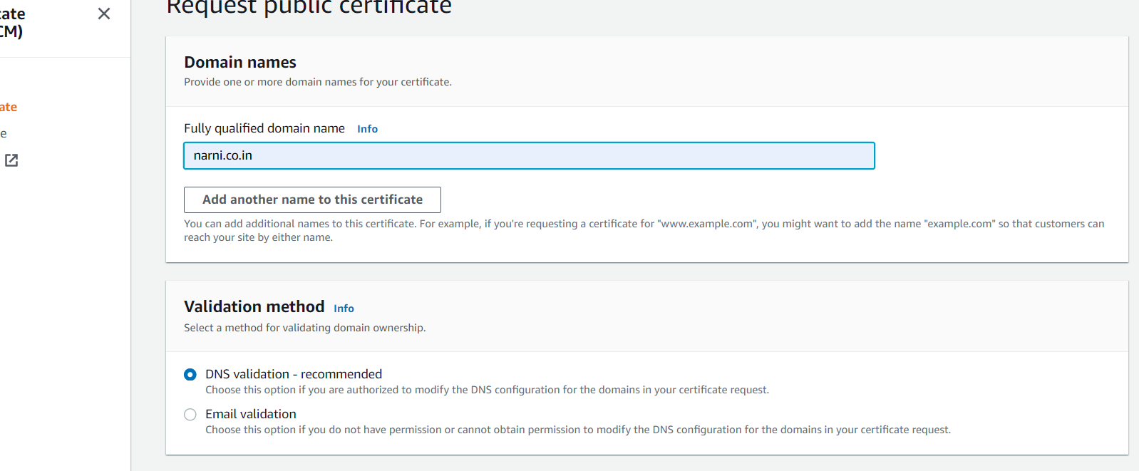

Click on request

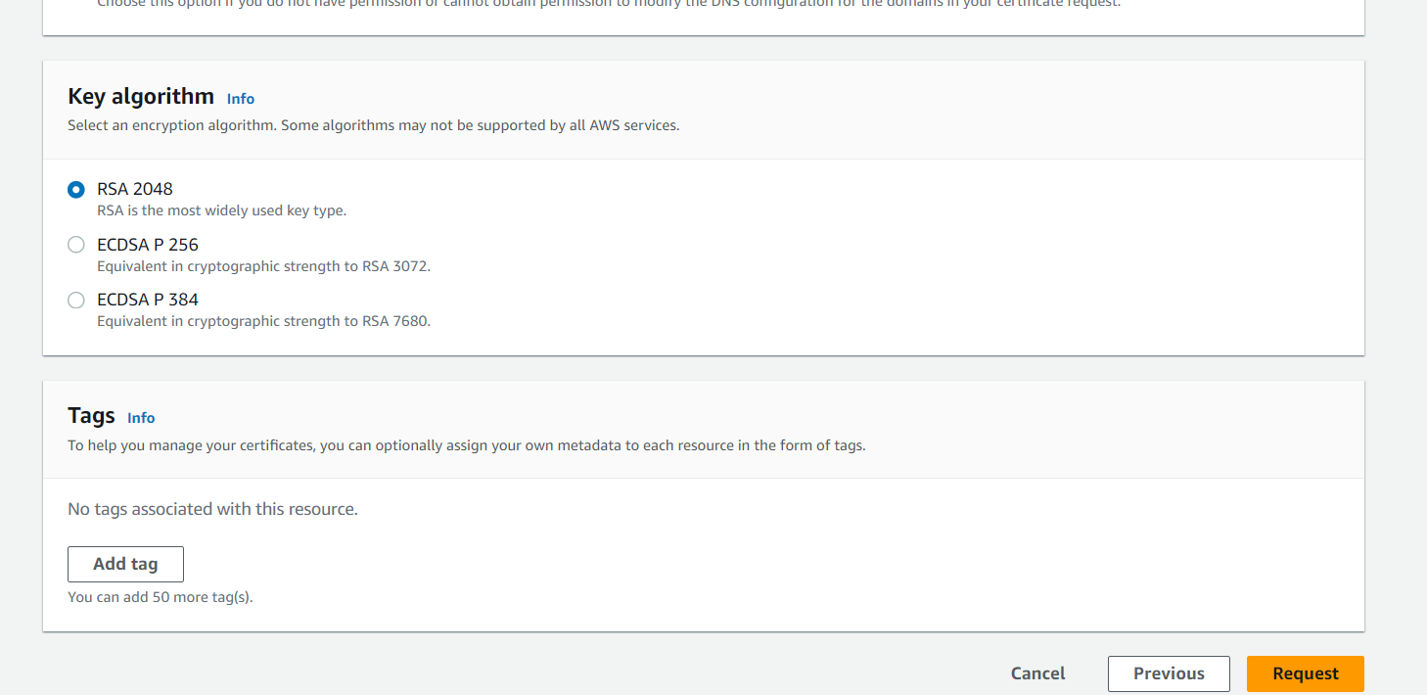

This is your certificate

Click on certificate id.

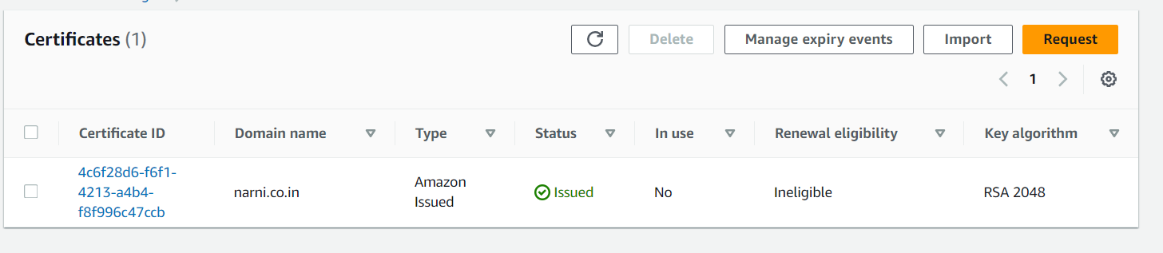

Click on create records in route 53

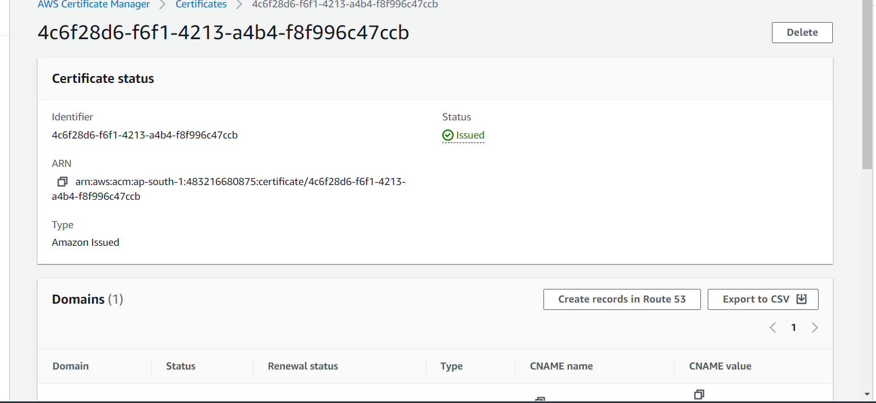

Click on create records

it will be added in to route 53 records list

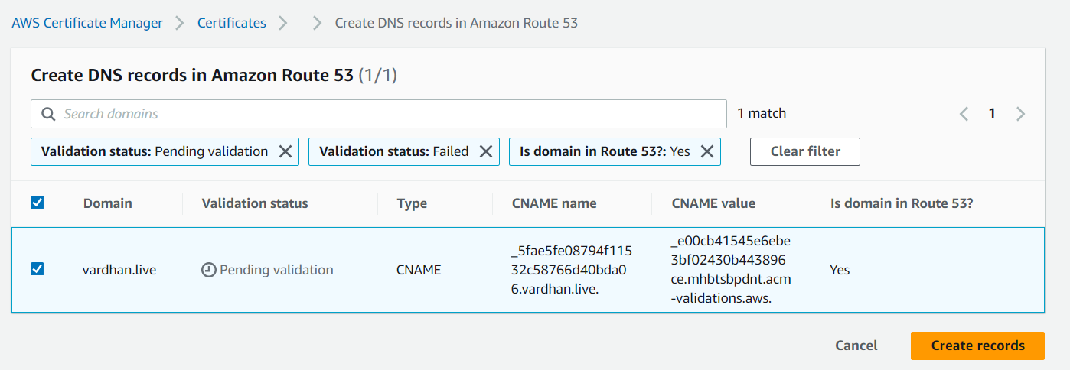

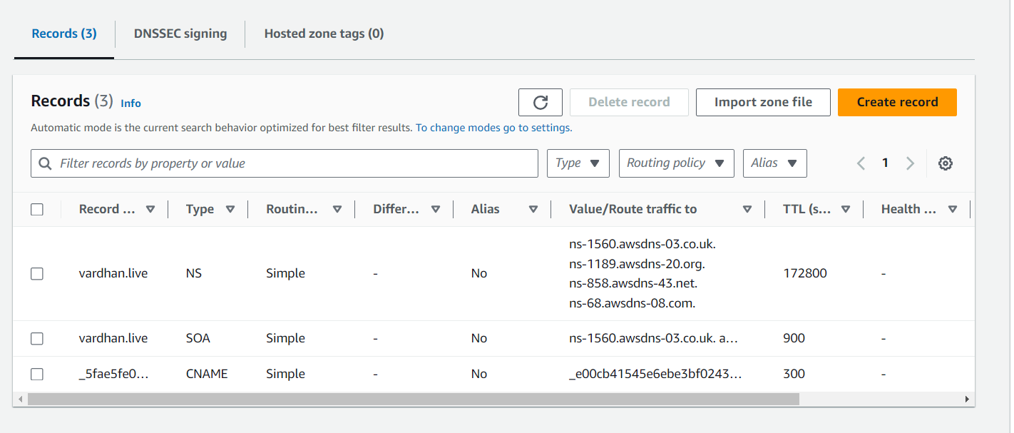



Then create a instance and add user data or manually connect to instance and install httpd server and check with public ip

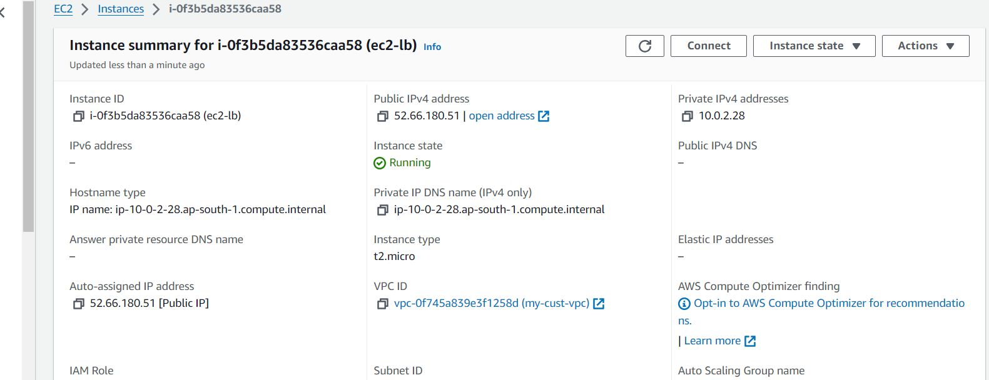

Crete a target group for above instance

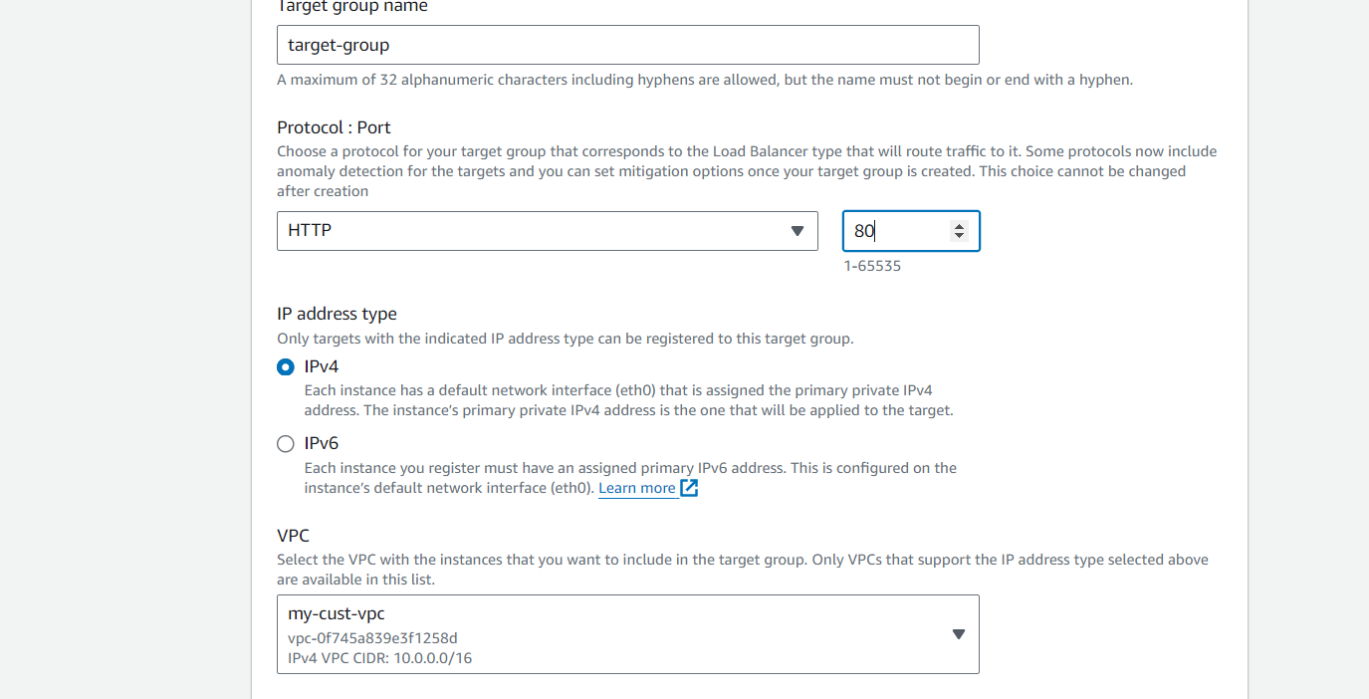

Mention your health check path as your application path

Then click on next

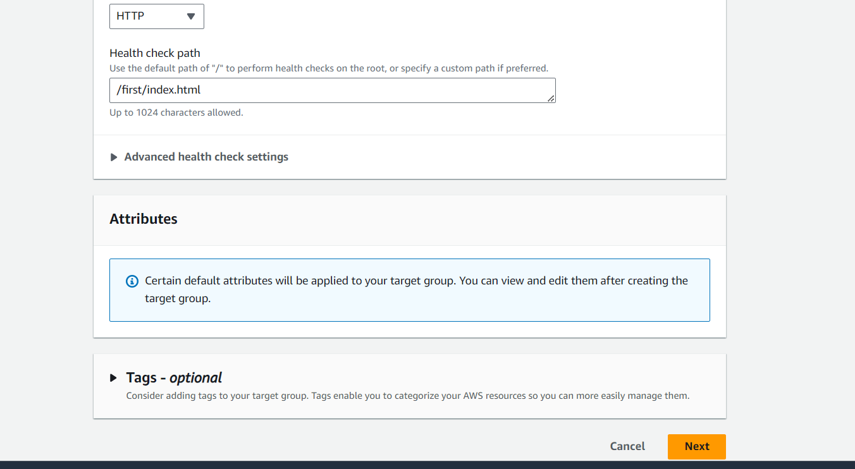

Select your instance and create a target group

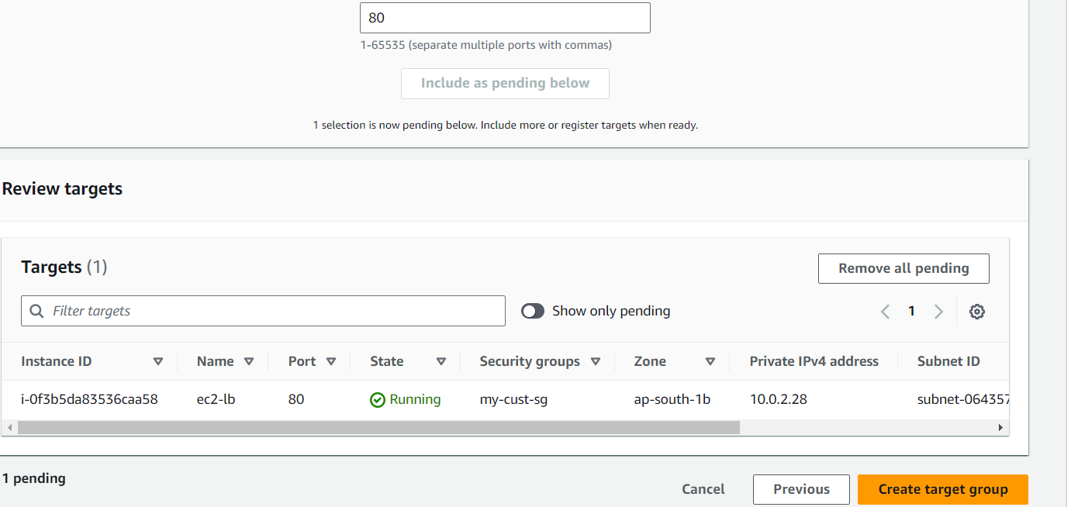

Next create a load balancer

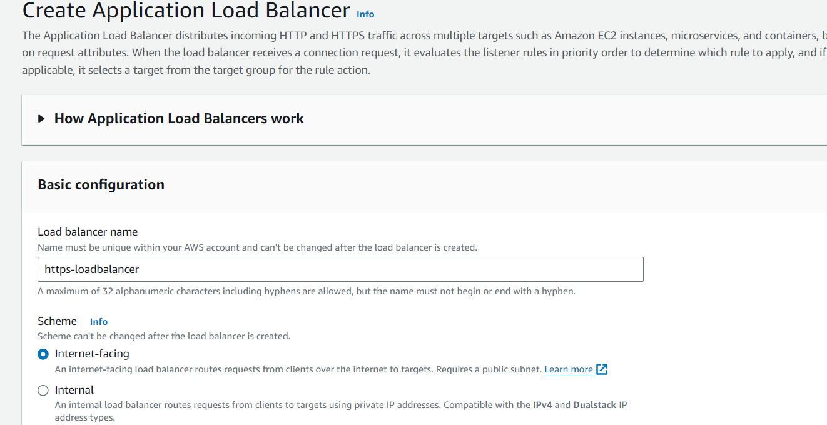

Select you subnets

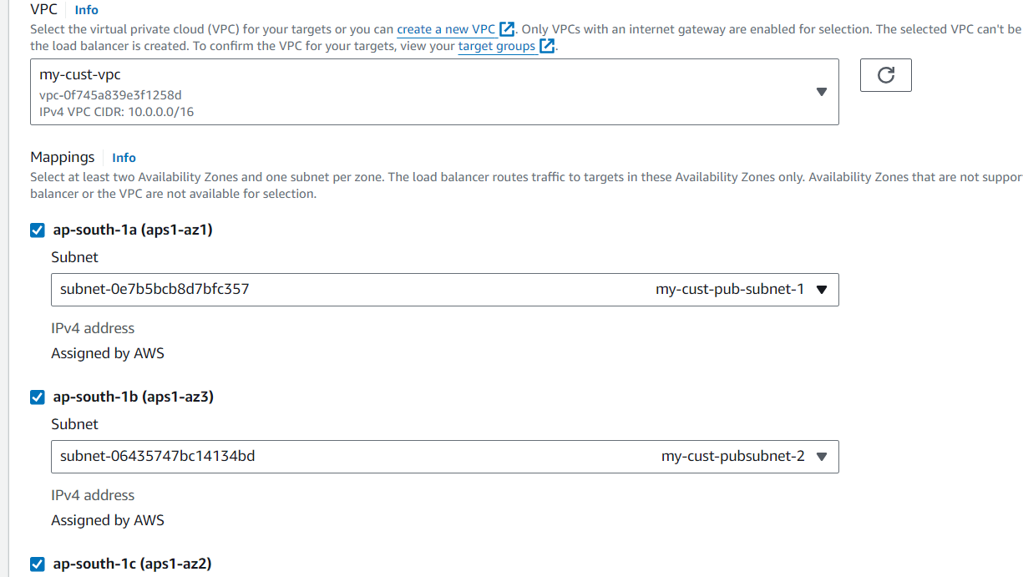

THIS IS MAJOR STEP FOR HTTPS

Select protocol as https

And select you target group

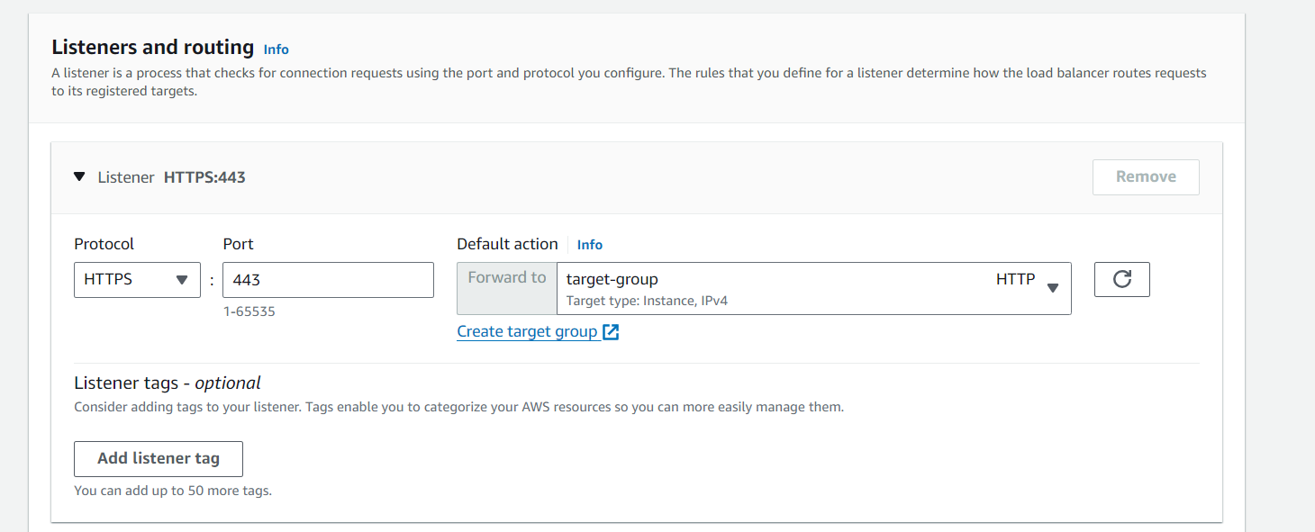

Security policy as it is

Select you certificate here this certificate comes from certificate manager you previously created

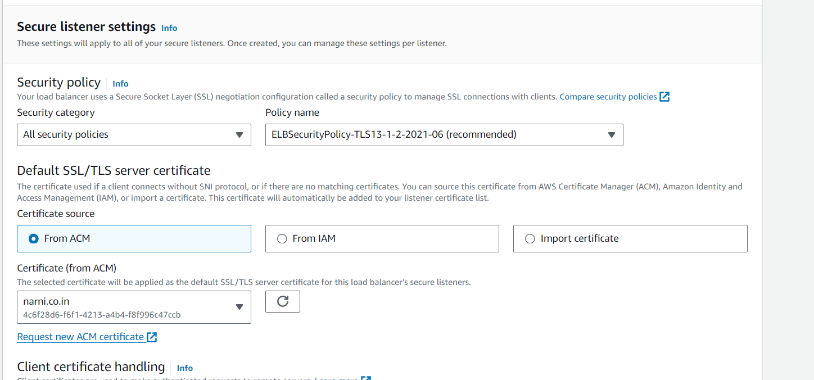



Click on create load balancer

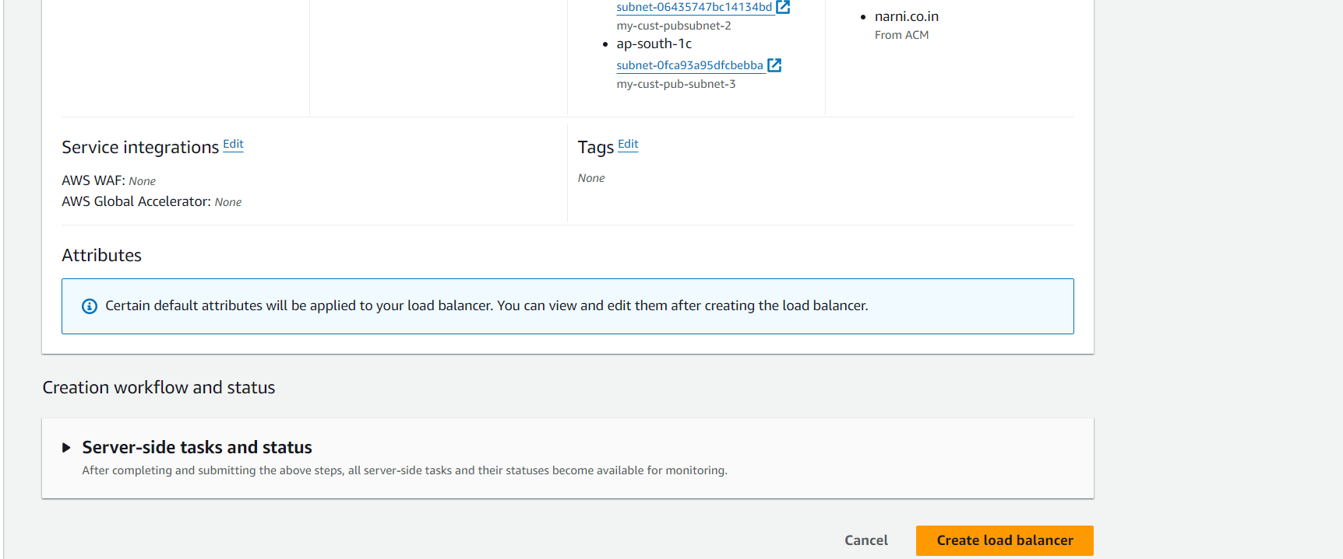

Then open your route 53

Click on create record

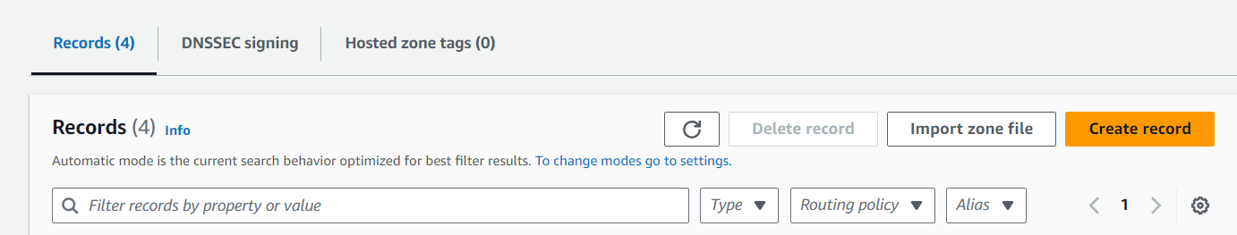

Select alias record

Type = alias to application and classic load balancer

Region= your load balancer region

Select your load balancer dns url

Click on create record

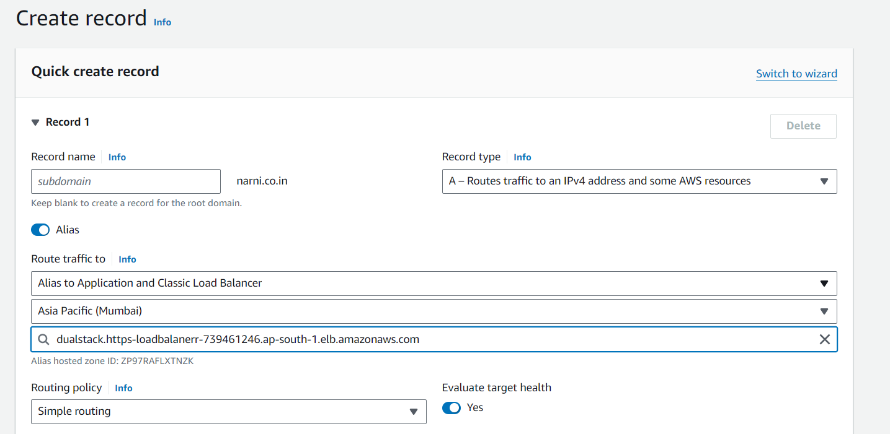

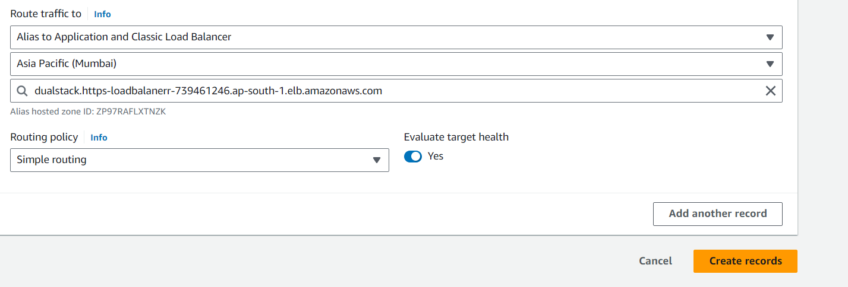

This is your record

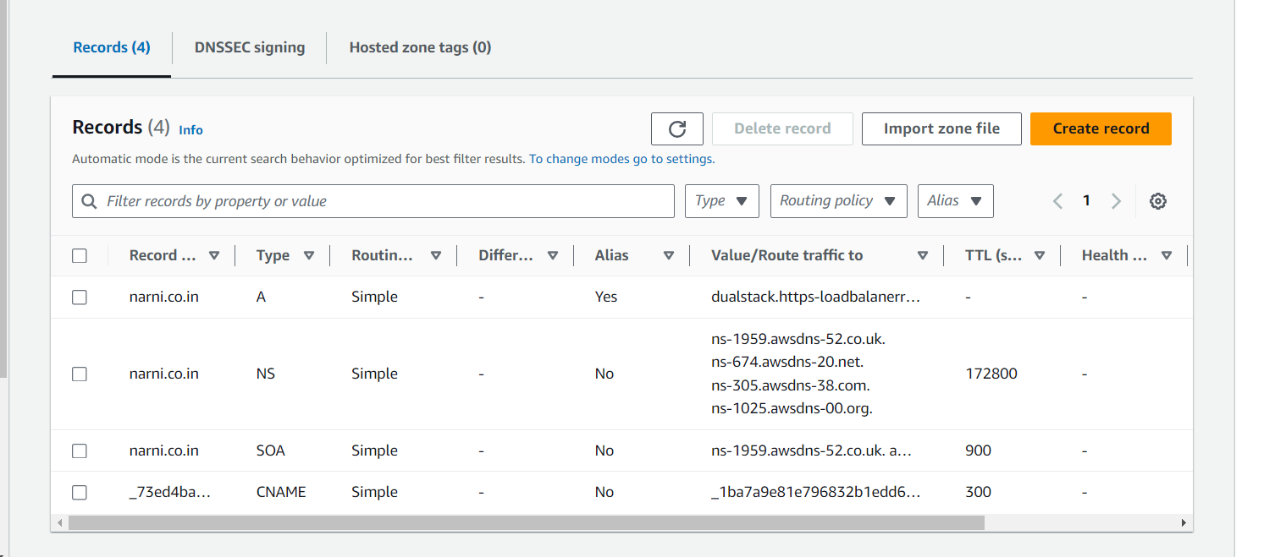



Hit with your domain name

https working successfully



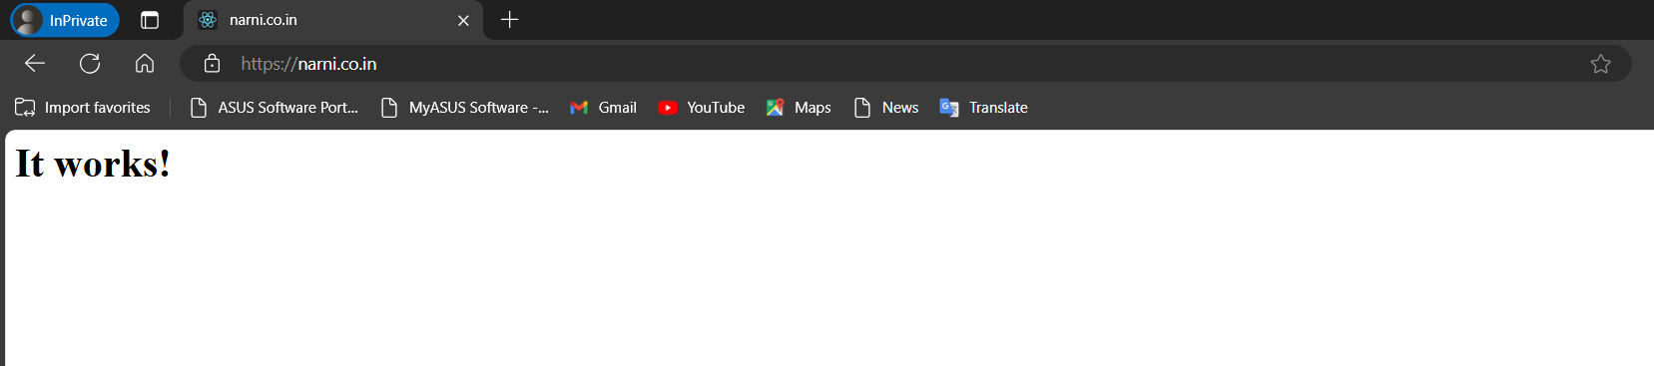



thankyou

